Barbara Blake was a teacher at Orange Glen Elementary in Escondido, California for 25 years. Barbara’s family wished to honor her memory by endowing a scholarship in her name. Friends and Colleagues joined with the family to honor Barbara by creating the perpetual Barbara Blake Memorial Scholarship.

The Family expressed their desire for recipients to be high school seniors from the Escondido Union High School District who had attended Orange Glen Elementary School in the Escondido Union School District.

This scholarship is for a total award amount of $2,000. The recipient, upon proof of enrollment as a full-time student (12 semester units or more), proof of registration and proof of class completion with a minimum GPA of 3.0, will receive this amount in two payments of $1,000; one payment at the completion of the first year, and one payment at the completion of the second year.

Application Procedures

A Complete Application Includes:

______ Applicant Information

______ Applicant’s Statement (Maximum of 200 words)

______ School/Community Activity Record

______ Official Transcripts

______ Letter of Recommendation #1 (School Employee: Teacher, Counselor, Administrator, Coach)

______ Letter of Recommendation #2 (School Employee: Teacher, Counselor, Administrator, Coach)

______ Letter of Recommendation #3 (Community Member: Someone who knows the applicant primarily outside of the school setting.)

Directions:

- Applications that do not follow the directions or applications that are incomplete will not be considered.

- Applications that are not signed by the applicant affirming that he or she intends to enter an accredited school of higher learning are considered incomplete.

- The ENTIRE APPLICATION must be submitted in one envelope *
*Letters of Recommendation and transcripts may be sent separately, but must be postmarked by Tuesday, April 5th, 2016.

- The Application Envelope may be mailed to:

Escondido Elementary Educators Association
Attn: Scholarship Committee
P.O. Box 548
Escondido, CA 92033

or scanned and emailed as a PDF document to:

eeeaoffice@gmail.com

- Applications must be postmarked by Tuesday, April 5th, 2016.

Questions? Call 760.746.1438 and ask for Jesusa Lopez or email eeeaoffice@gmail.com

Applicant Information

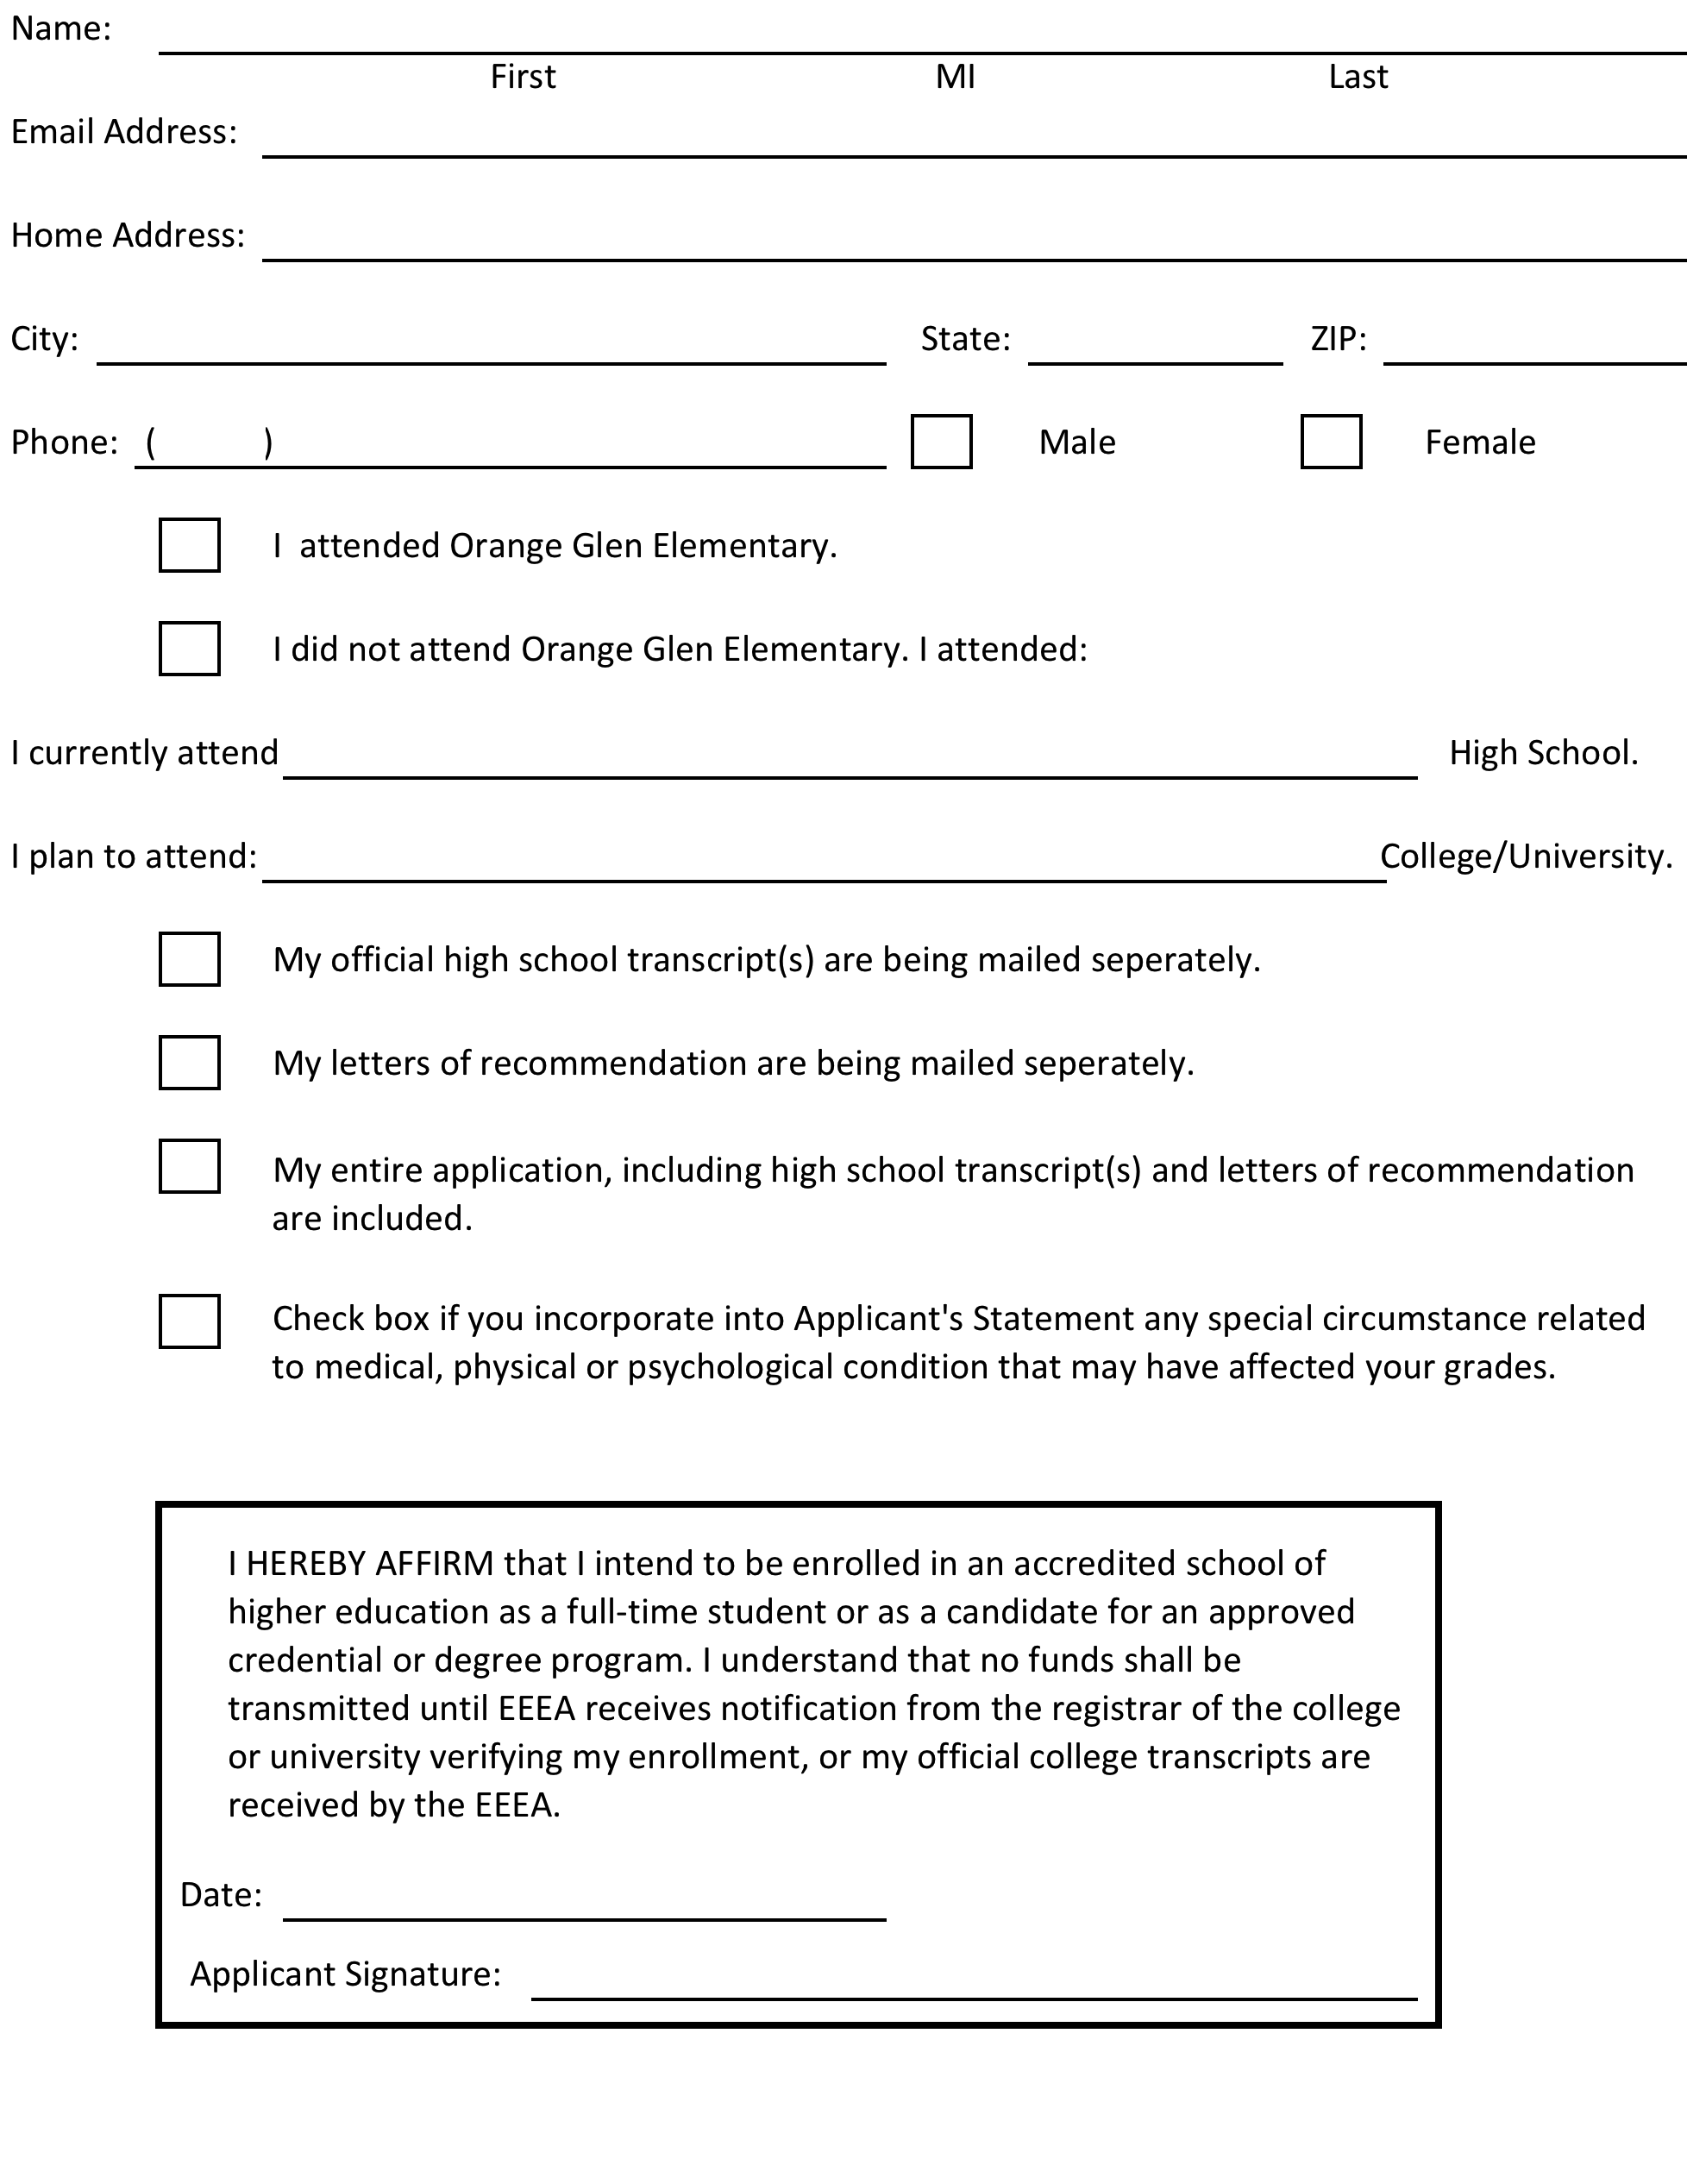

________________________________

Personal Statement and School/Community Record Directions

Personal Statement:
- Please describe your personal attributes, unique qualities and future goals in a MAXIMUM of 200 words on another sheet of paper. Longer statements will not be read beyond 200 words.
- You may incorporate an explanation of any special circumstances related to medical, physical, or psychological condition that may have affected your grades.

School/Community Record Directions:
- Please provide information regarding your participation in your school and community in the following five categories on another sheet of paper.
- Specify any offices held and note years of participation.
- Bullet Points Recommended

School/Community Record Categories:

- School Organizations/ Activities:
- Awards/ Honors/ Achievements:
- Community Organizations/ Activities:
- Employment:
- Personal Achievements:

Letter of Recommendation

Applicant’s Name: ______________________________________________________________

Please do not hand write.

Type on a separate page and attach typed letter of recommendation.

When writing the letter of recommendation, please address each category:

- Involvement in and sensitivity to social and civic issues.
- Characteristics such as responsibility, reliability and integrity.
- Academic and vocational potential.
- Special and personal achievements.

Attach recommendation to this form. Return to applicant. If you would prefer, you may send it directly to the EEEA at:

EEEA
Attn: Scholarship Committee
PO Box 548,
Escondido, CA 92033

Signature: ____________________________________________________________________________

Printed Name: _______________________________________________________________________
Check One: ☐ School Employee ☐Community Member

Company/ Organization: ___________________________________________________________

Relation to Applicant: _______________________________________________________________

Number of year(s) you have known applicant: ___________________________________

Date: __________________________________________________________________________________

Letter of Recommendation

Applicant’s Name: ______________________________________________________________

Please do not hand write.

Type on a separate page and attach typed letter of recommendation.

When writing the letter of recommendation, please address each category:

- Involvement in and sensitivity to social and civic issues.
- Characteristics such as responsibility, reliability and integrity.
- Academic and vocational potential.
- Special and personal achievements.

Attach recommendation to this form. Return to applicant. If you would prefer, you may send it directly to the EEEA at:

EEEA
Attn: Scholarship Committee
PO Box 548,
Escondido, CA 92033

Signature: ____________________________________________________________________________

Printed Name: _______________________________________________________________________
Check One: ☐ School Employee ☐Community Member

Company/ Organization: ___________________________________________________________

Relation to Applicant: _______________________________________________________________

Number of year(s) you have known applicant: ___________________________________

Date: __________________________________________________________________________________

Letter of Recommendation

Applicant’s Name: ______________________________________________________________

Please do not hand write.

Type on a separate page and attach typed letter of recommendation.

When writing the letter of recommendation, please address each category:

- Involvement in and sensitivity to social and civic issues.
- Characteristics such as responsibility, reliability and integrity.
- Academic and vocational potential.
- Special and personal achievements.

Attach recommendation to this form. Return to applicant. If you would prefer, you may send it directly to the EEEA at:

EEEA
Attn: Scholarship Committee
PO Box 548,
Escondido, CA 92033

Signature: ____________________________________________________________________________

Printed Name: _______________________________________________________________________
Check One: ☐ School Employee ☐Community Member

Company/ Organization: ___________________________________________________________

Relation to Applicant: _______________________________________________________________

Number of year(s) you have known applicant: ___________________________________

Date: __________________________________________________________________________________

